# Steps for Signal Control

Step1. Input Formation

**Movement volume and number of lanes:**

|  |  |  |  |  |  |  |  |  |  |  |  |  |
| --- | --- | --- | --- | --- | --- | --- | --- | --- | --- | --- | --- | --- |
| **Movement** | EBL | EBT | EBR | WBL | WBT | WBR | NBL | NBT | NBR | SBL | SBT | SBR |
| **Volume** |  |  |  |  |  |  |  |  |  |  |  |  |
| **No. of lanes** |  |  |  |  |  |  |  |  |  |  |  |  |
| **Shared lanes** |  |  |  |  |  |  |  |  |  |  |  |  |

Step2. Determine left turn treatment

1. **Left-turn Lane Check**

Criterion: If the number of left-turn lane on any approach exceeds 1, then it is recommended that the left turns on that approach be protected.

1. **Minimum Volume Check**

Criterion: If left-turn volume on any approach exceeds 240 veh/h, then it is recommended that the left turns on that approach be protected.

1. **Opposing Through Lanes Check**

Criterion: If there are more than 4 or more through lanes on the opposing approach, then it is recommended that the left turns on that approach be protected.

1. **Opposing Traffic Speed Check**

Criterion: If the opposing traffic speed exceeds 45mph, then it is recommended that the left turns on that approach be protected.

1. **Minimum Cross-Product Check**

Criterion:

Protected+permissive:

|  |  |
| --- | --- |
| **Number of Through Lanes** | **Minimum Cross-Product** |
| 1 | 50000 |
| 2 or more | 100000 |

Protected only:

|  |  |
| --- | --- |
| **Number of Through Lanes** | **Minimum Cross-Product** |
| 1 | 150000 |
| 2 or more | 300000 |

Calculation: cross-product for each left-turn

|  |  |  |  |  |
| --- | --- | --- | --- | --- |
| **Movement** | EBL | WBL | NBL | SBL |
| **Opposing Through Lanes** |  |  |  |  |
| **Cross-Product** |  |  |  |  |
| **Exceed Protected Minimum Cross-Product?(Y/N)** |  |  |  |  |
| **Exceed Protected+Permissive Minimum Cross-Product?(Y/N)** |  |  |  |  |
| **Protected decision** |  |  |  |  |

Thus, WBL and NBL left-turns should be protected, and EBL and SBL should be treated as permissive+protected according to this criterion. Based on the analysis above, we can come up with the left-turn final decision.

**Left-turn Final Decision**

|  |  |  |  |  |
| --- | --- | --- | --- | --- |
| **Movement** | EBL | WBL | NBL | SBL |
| **Left-turn Treatment** |  |  |  |  |

Step3. Determine Ring-Barrier Structure and Movements

|  |  |  |  |  |
| --- | --- | --- | --- | --- |
|  | **Final Ring-Barrier Structure** | | | |
| **Ring1** |  |  |  |  |
| **Ring2** |  |  |  |  |

|  |  |  |  |  |
| --- | --- | --- | --- | --- |
|  | **Final Ring-Barrier Movement** | | | |
| **Ring1** |  |  |  |  |
| **Ring2** |  |  |  |  |

Step4. Adjust Lane Volumes(Calculate Analysis Flow Rate)

1. **Right-turn Movement**

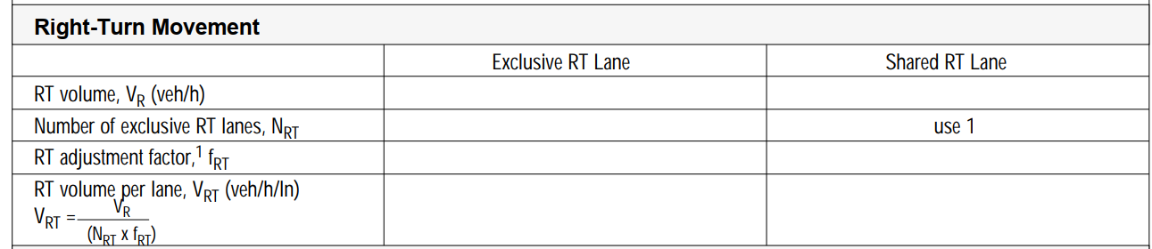

1. **Left-turn Movement**

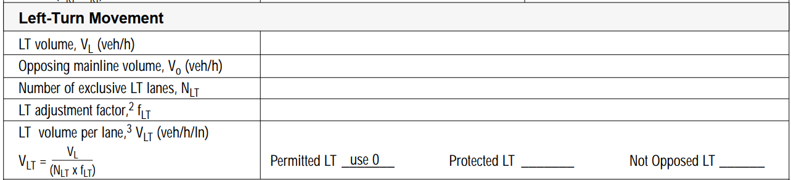

1. **Through Movement**

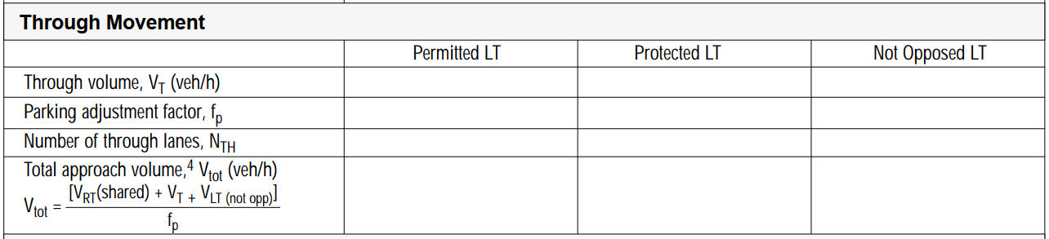

1. **Through Movement with exclusive LT lane & shared LT lane**

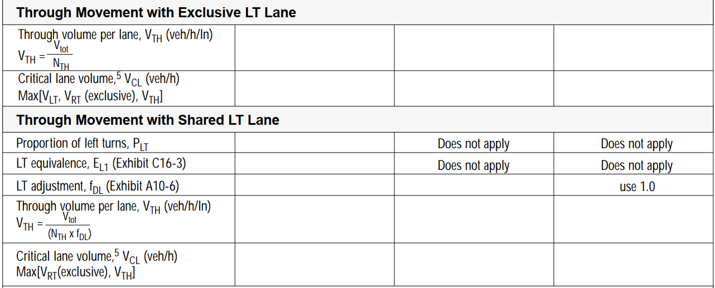

1. **Saturation flow rate**

**for protected phase:**

The default value of saturation flow rate for protected phase is 1530veh/h/lane

$$\text{Saturation flow rate = 1530*}\text{num_of_left_turn_lanes}\text{*PHF} \text{(}\text{veh}\text{/h)}$$

**for permissive phase(for left-turn):**

The default value of saturation flow rate for permissive phase is 150-200veh/h/lane

$$\text{Saturation flow rate = }{\text{f}}_{\text{lu}}\text{*}{\text{f}}_{\text{hv}}\text{*}\text{opposing_volume}\text{*}\frac{{\text{e}}^{\text{-}\text{opposing_volume}\text{*4.5/3600}}}{\text{1-}{\text{e}}^{\text{opposing_volume}\text{*2.5/3600}}}$$

Step5. Determine Critical Lane Group

To determine critical lane group for each stage, we can should select the lane group with maximum v/s(v: volume, s: saturation rate) for each stage.

Step6. Calculate sum of the flow ratios

The sum of the flow ratios for the critical lane groups for this phasing plan will be needed for the next section. Since this phasing plan does not include any overlapping phases, this value is simply the sum of the highest lane group v/s ratios for the three stages, as follows:

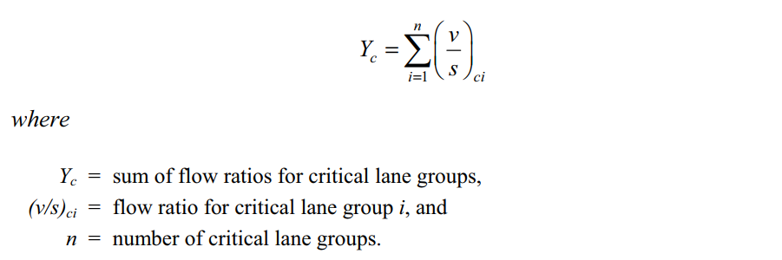

Step7. Calculate total cycle lost time

The total lost time for the cycle will also be used in the calculation of cycle length. In determining the total lost time for the cycle, the general rule is to apply the lost time for a critical lane group when its movements are initiated (the start of its green interval). The total cycle lost time is given as

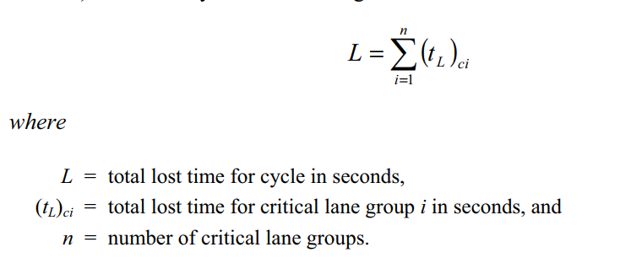

Step8. Calculate minimum Cycle Length and Optimal Cycle Length

1. **calculation of minimum cycle length:**

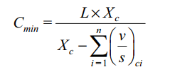

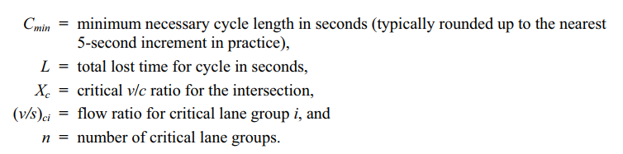

1. **calculation of optimal cycle length:**

A practical equation for the calculation of the cycle length that seeks to minimize

vehicle delay was developed by Webster. Webster’s optimum cycle length

formula is

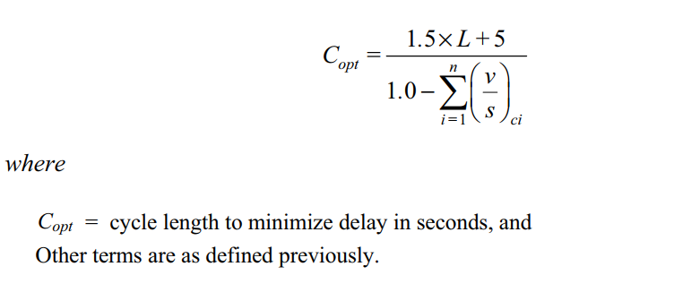

The cycle length determined from this calculation is only approximate. Webster noted that values between 0.75*Copt* and 1.5*Copt* will likely give similar values of delay. Calculating an accurate optimal cycle length (and phase length) can be a very computationally intensive exercise for all but the simplest signalized intersections, especially if coordination among multiple signals is involved.

Step9. Allocate green time and calculate effective green time

There are several strategies for allocating the green time to the various phases. One of the most popular and simplest is to distribute the green time so that the *v*/*c* ratios are equalized for the critical lane groups, as by the following equation:

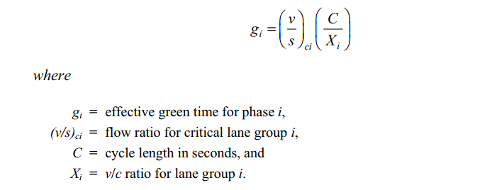

Effective green time is calculated as follows:

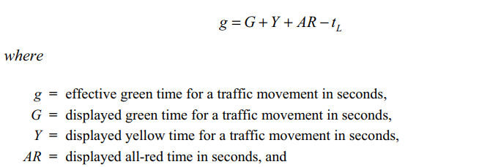

Step10. Calculate capacity and ratio V/C

Capacity can be calculated as follows:

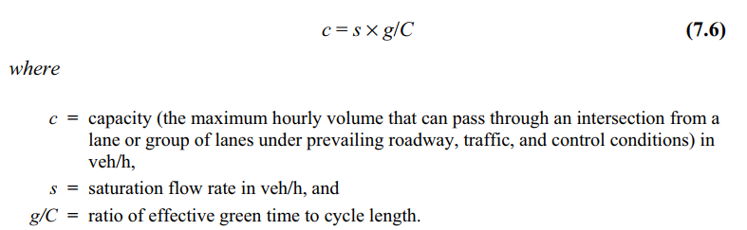

Then we can calculate ratio V/C.

Step11. Calculate Signal Delay and LOS

1. **Average Uniform Delay**

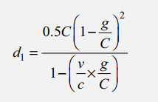

1. **Average Incremental Delay**

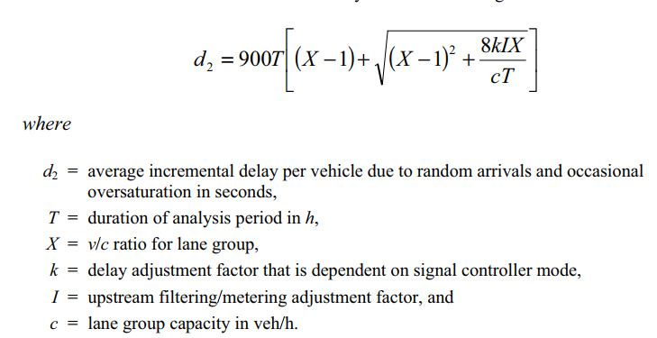

1. **Control Delay**
$$\text{Control Delay = Average Uniform Delay} \text{+} \text{Average Incremental Delay }$$

2. **Approach Delay**

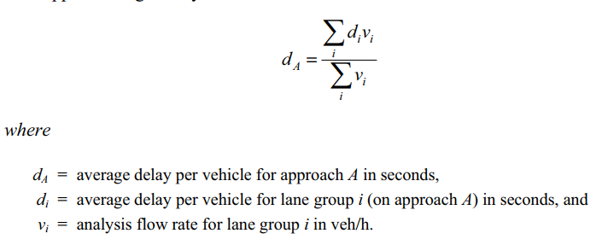

1. **Intersection Delay**

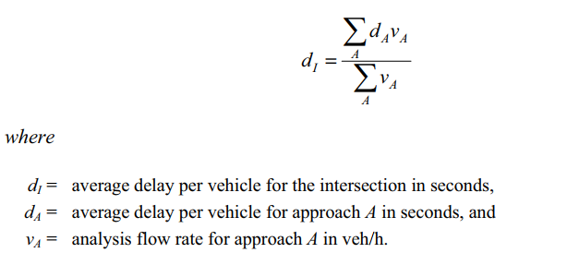

1. **LOS for each lane group, each approach and the intersection**

The corresponding relationship between LOS and control delay is shown as follows:

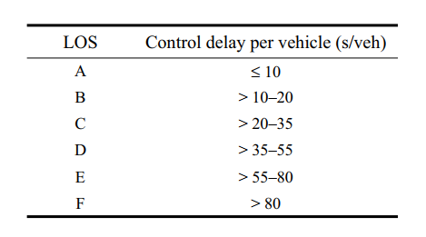

References

Traffic Control Systems Handbook <https://ops.fhwa.dot.gov/publications/fhwahop06006/>

Traffic Signal Timing Manual <https://ops.fhwa.dot.gov/publications/fhwahop08024/>

Signalized Intersections: Informational Guide <https://www.fhwa.dot.gov/publications/research/safety/04091>